OPTIMAL METHOD SPACE IS O(N)::
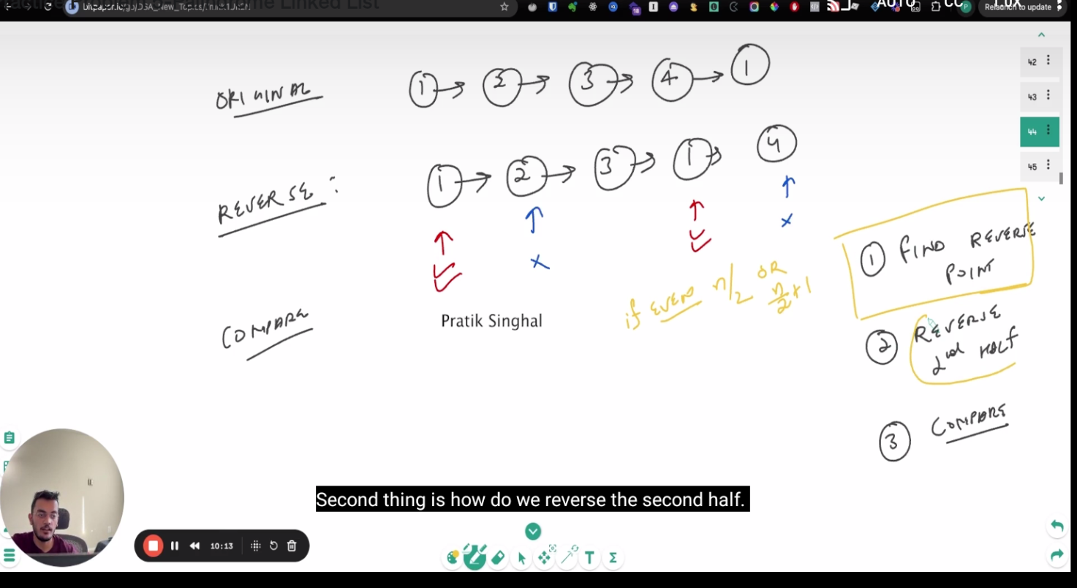
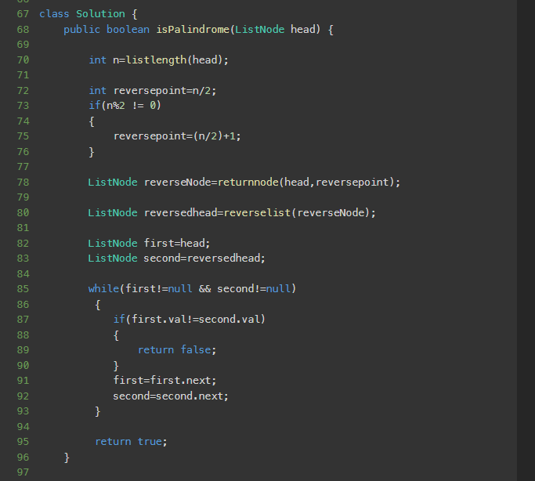
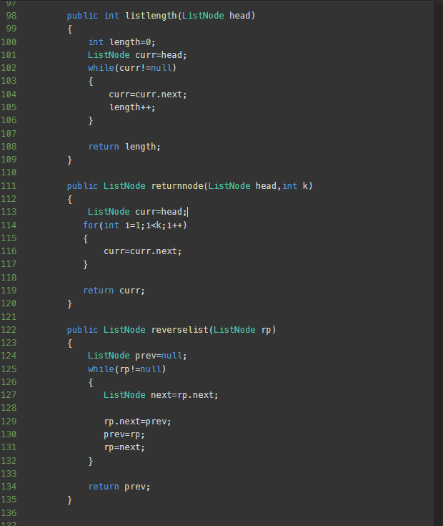

THE OTHER METHOD IS COPYING THE ENTIRE LIST AS DUPLICATE AND THEN REVERSING IT , THEN CHECKING THE TWO LIST FOR PALINDROME;
LINK:
https://leetcode.com/problems/palindrome-linked-list/submissions/1977465993

